School: Tan Tien Primary school  Full name: ………………………  Class: 4 …… | THE FIRST SEMESTER TEST  ENGLISH – GRADE 4  SCHOOL YEAR: 2020 - 2021  Time: 35 minutes

Marks | Listening | Reading | Writing | Speaking | Total
Remark | ………………………………………………………………………………………………………………………………………………………………

PART I. LISTENING (3pts).

Question 1. Listen and number.

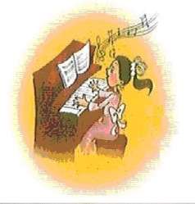 | 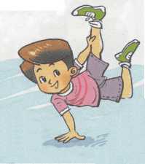 | 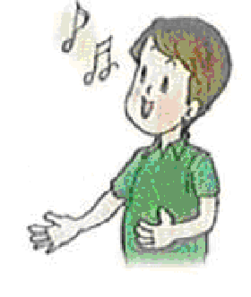 | 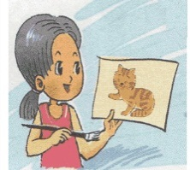 | 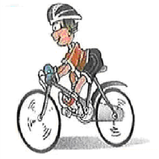
0
- c. d. e.

Question 2. Listen and tick.
0. a. 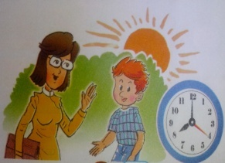 b. 

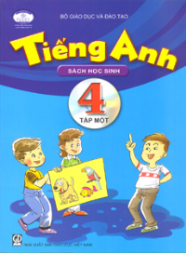
1. a. 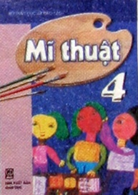 b. 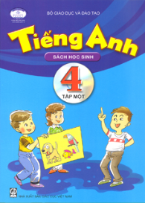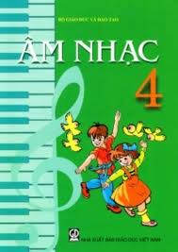

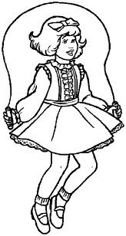
2. a.  b.
3. a. 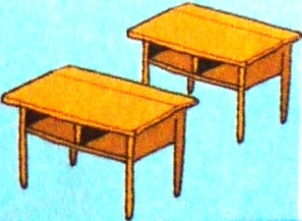 b. 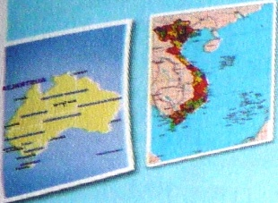
4. a. 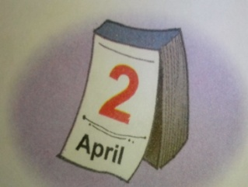 b. 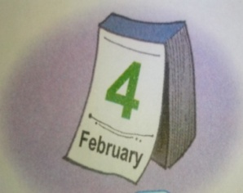
Question 3. Listen and complete.
A: What is (0) your hobby?
B: (1) ___________.
C: I like playing the (2) ___________.
A: My (3) ___________ is singing.
B: We all like (4) ___________. Let’s go to the music club.
PART II- READING (3pts).
Question 4: Look and read .Put a tick ( ) or a cross () in the box.
 | 0. My birthday is on the fifteenth of August. | X
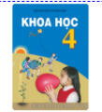 | 1. My favourite subject is Music.
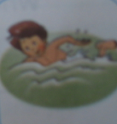 | 2. Nam can swim.
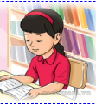  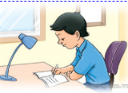
  3. She is listening to music.
  4. He’s writing a dictation.

Question 5: Fill in each gap with a suitable word from the box.
Primary | sing | November | Viet Nam | name
Hi. My (1)name is Nam. I’m from (2) _____________. I’m 11 years old. My birthday is on the third of (3)____________.I study at Le Hong Phong(4)_____________School. I like Music very much. In my free time, I go to Music club. I can (5)______________ but I can’t play the piano.
Question 6: Read and match. (1pt).

1. What nationality are you, Akiko? | a. It’s in Nguyen Du street. | 1-
- What day is it today? | b. I am Japanese. | 2-
3. What subjects do you have today? | c. It’s Thursday. | 3-
4. Where is your school? | d. I have Maths, Music and Vietnamese. | 4-

PART III.WRITING (2pts).
Question 7: Look at the pictures and the letters. Write the words.
1. apino |  | piano
2. aEngndl |  | ___________
3. ngElshi | 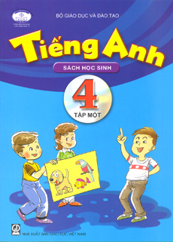 | __________
4. Good nimorng | 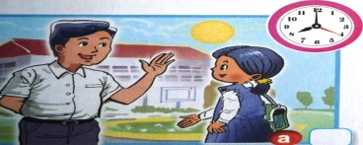 | Good __________
5. tOcbero |  | __________

Question 8. Reoder the words to make the sentences (1point).
- What / you? / nationality / are

…………………………………………………………………………………
- is/ your / When / birthday?

…………………………………………………………………………………
- Mai / painting / a mask. / is

…………………………………………………………………………………
- Where / yesterday? / were / you/

…………………………………………………………………………………….
PART IV: SPEAKING (2 point)
Part 1: Getting to know each other (1.0point)
Part 2: Talking about a familiar object (0.5 point)
Part 3: Describing the picture (0.5 point)

Họ, tên giáo viên coi, chấm: ..............................................

